**1 Site Introduction**

Case Study Butterfly Bay / HuDieWan Compound in Suzhou Industrial Park

The site we examined was constructed twenty-five years ago in Yangtze River delta in Suzhou and its Industrial Park (SIP). It is observed that residential developments in Suzhou Industrial Park (SIP) is repetitive and monotonous. We attempted to utilize a shape grammar mechanism to generate design options and evaluate efficiently as a parametric system.

We studied a housing development at SIP. First, we analyzed the mandatory building parameters according to the regulations. Then we employed various shape grammars and daylight analysis for the generative and evaluative system to improve the current housing development.



**Fig. 1.** Repeated tower at the case study HuDieWan

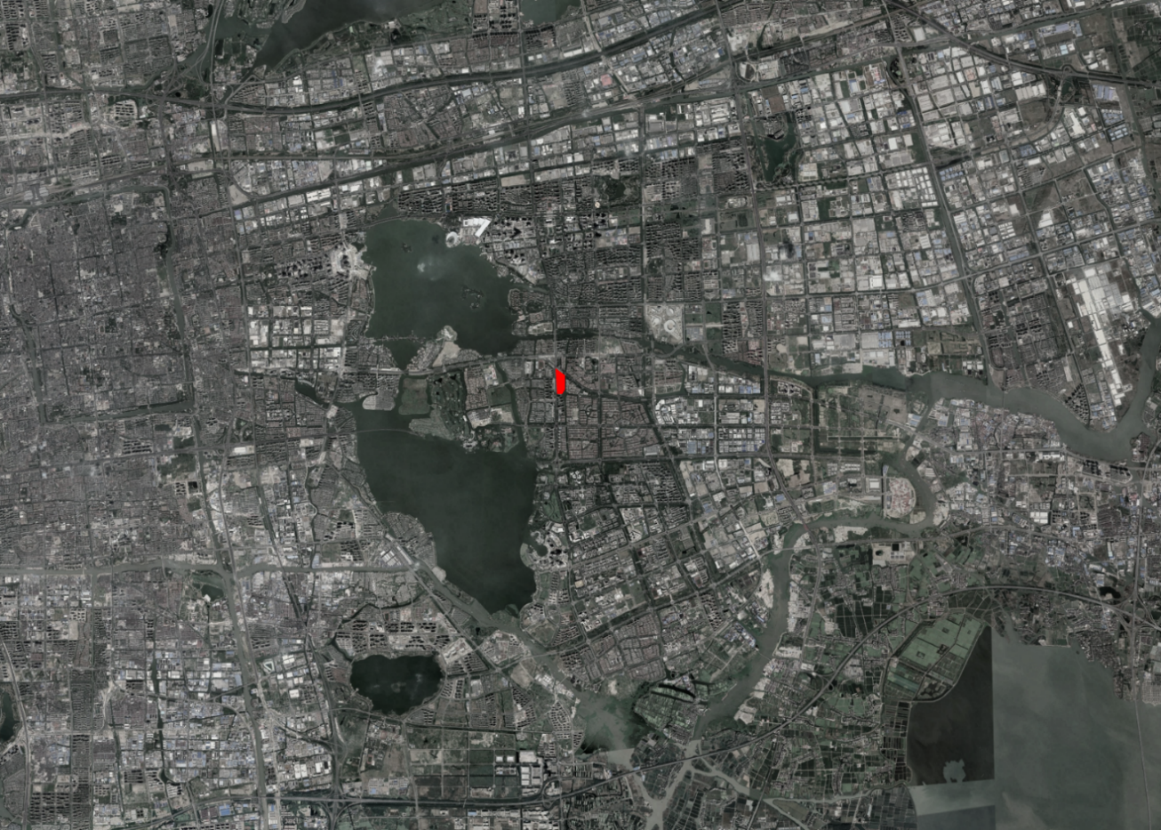

**Fig. 0.** Suzhou Industrial Park with red hatch indicating the location of the case study HuDieWan or Butterfly Bay compound.

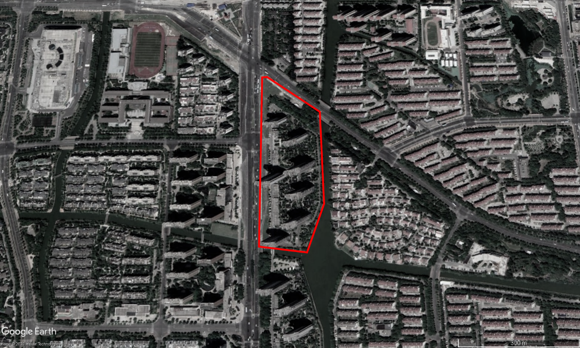

**Fig. 0.** Red line indicating the site boundary of the case study HuDieWan or Butterfly Bay compound

**2 Research Method**

**Setting Parameters and criteria for the sunlight analysis**

The basic parameter to be included into the algorithm are taken from the official building code for Jiangsu Province (including SIP area), ‘Jiangsu Province City planning and technical specification – Suzhou implementation detail 2 - “daylight analysis rules” (2018 version)’ In Chinese: 《江苏省城市规划管理技术规定--苏州市实施细则之二“日照分析规则”（2018年版）》).

(<http://www.zfxxgk.suzhou.gov.cn/sjjg/szsghj/201812/t20181207_1034143.html>)

For residential building, there should be no less than two direct daylight hours a day on the main facade on Great Cold day (20 January 2001). Time interval for analysis sample is one minute and analysis grid size should be less or equal to 1m x 1m. For SIP, the testing coordination is North latitude 31° 19’, East longitude 120° 37’.

For effective comparison between different design options based on the generated shapes, we maintain the number of buildings (i.e. seven), building locations, building width (~25m) and building heights (100m) as same as the current built development on site. It can also other parameters of the buildings (except daylight requirement) already compile with the regulations.

**Implementation: Rhino- Grasshopper**

The computational modelling environment was Rhinoceros with Grasshopper operating shape grammar transformations and daylight simulations. We used the SortalGI plugin for setting up shape grammar rules and develop shape transformations. Then we used Sunflower plugin for running direct sunlight hour simulation.

The overall algorithm that describes the adopted workslow can be divided into five parts. First, we set up switches for running shape grammar transformations and sunlight analysis, followed by display options for different design alternatives and each building. Second, we set up shape grammar rules and shape transformation test sequences. Third, we turned the final shapes from tests into buildings. Fourth, Sunflower plugin runs daylight simulations for each option. Lastly, we extracted the simulation results from the main facades and check the data against the daylight regulations.

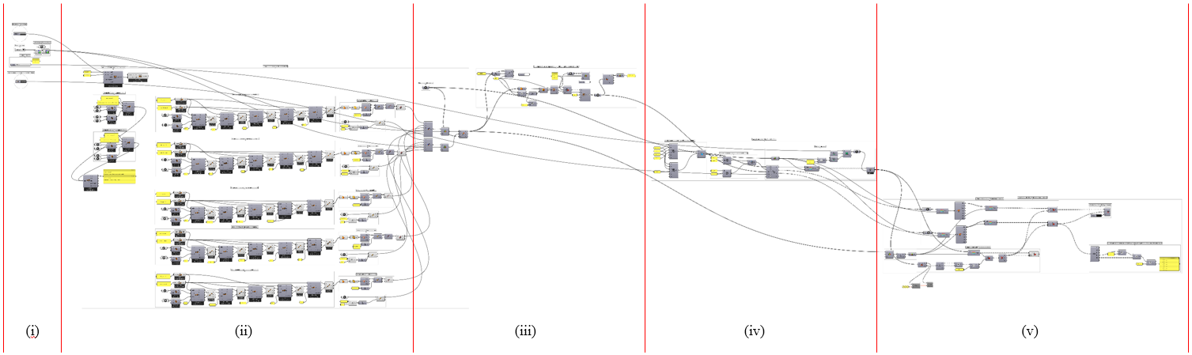

**Fig. 0.** Overall algorithm of daylight analysis: (i) setup, (ii) shape grammar, (iii) building modelling, (iv) daylight analysis, (v) extract main façade data

(i) Set up

There are two main functions for the set-up buttons. First, we can trigger the SortalGI shape grammar operations and Sunflower daylight analysis. Second, we can select which design option to display and which building main façade we want to display. The buttons are connected throughout the script that every selection will automatically update the building modelling, daylight simulation and main façade extraction. (Fig. 0)

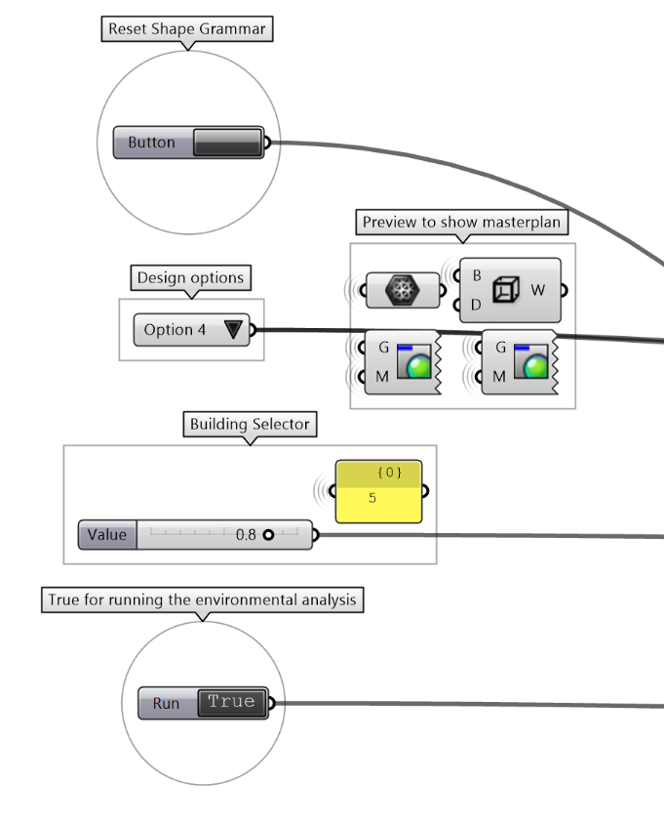

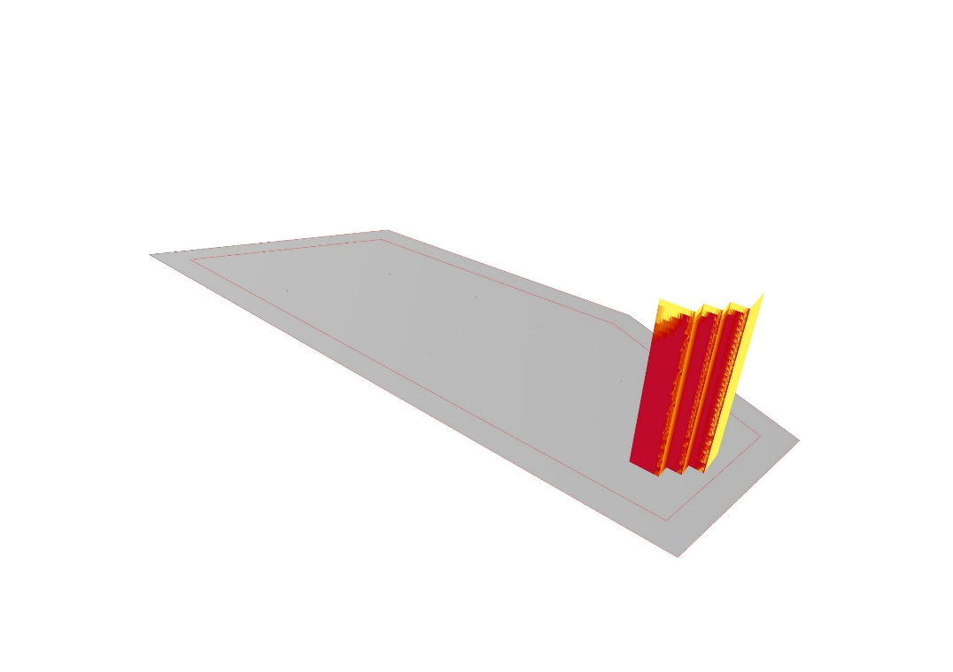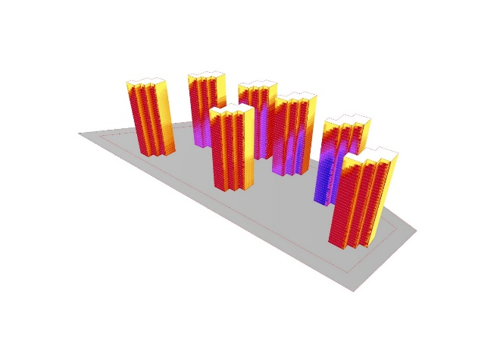

**Fig. 0.** (i) Set up – Left: Buttons for running building options generations, daylight simulation and result display options, Middle: display whole masterplan, Right: display main façade of specific building

(ii) Shape grammar building outlines generation

First, we studied the four basic transformation types of shapes. Then we used different combinations of transformation types to create three sets of tests. (Fig. 0 - rules)

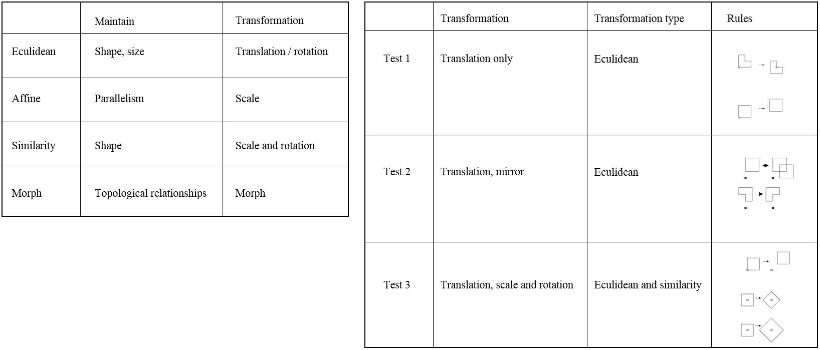

**Fig. 0.** (ii) Set up three shape grammar rules – Left: four basic transformation types from *AAD_Algorithms-Aided Design* pp.184; Right: our three shape grammar rules

In the algorithm for each test, we used SortalGI plugin to set up the two or three rules. Then, we generated five different shapes by different sequences of transformations. We then extracted the outlines of the five final shapes as the five building outline options. (Fig. 0 (ii) (ii)) Then, the clean building outlines were ready to be modelled in the next step.

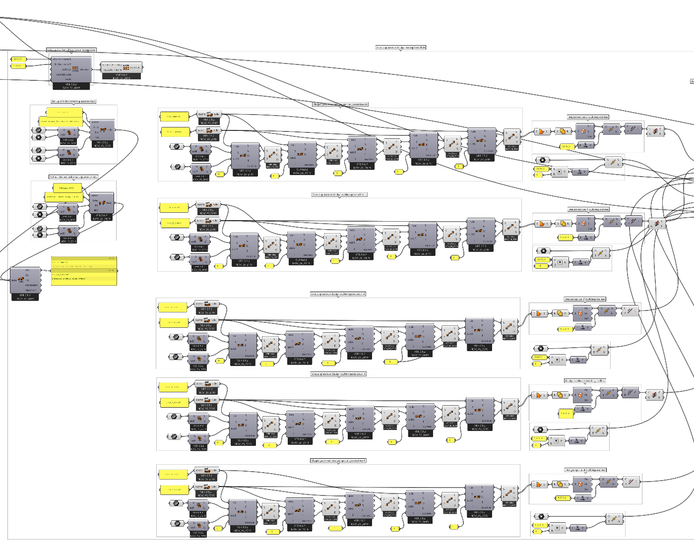

**Fig. 0.** (ii) Shape grammar – SortalGI algorithm of setting up rules, five transformations and obtaining building outlines

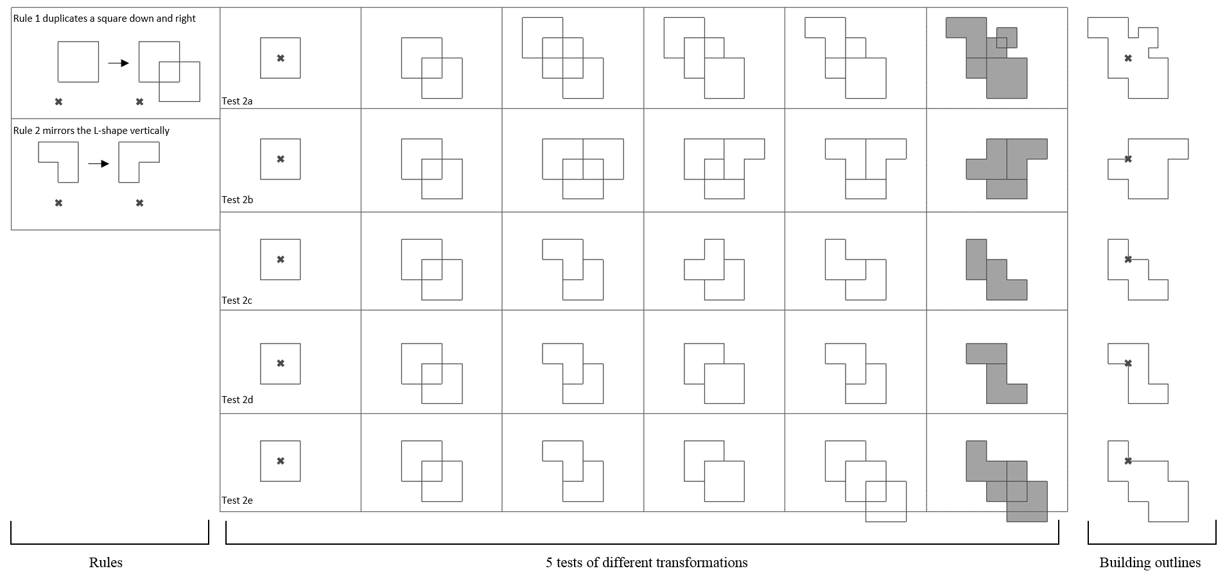

**Fig. 0.** (ii) Shape grammar – Rhinoceros interface displays the rules, five transformations and five final building outlines

(iii) Building modelling

For this step, we produced the masterplan model of seven towers with one building outline option each time. We worked by three steps. First, we mapped each building outline seven times to the seven points indicating the building locations. Second, we extruded the building outlines by 100m and provided contour lines indicating the 3m floor heights. Third, we refined the mesh density of all facades to ensure the biggest grid width was equal or less than 1m, in order to compile the requirement of daylight analysis specifications. (Fig. 0 – (iii))

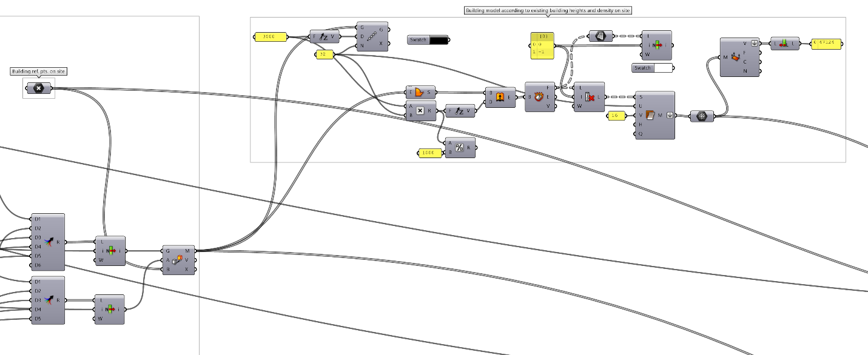

**Fig. 0.** (iii) Building modelling – Mapping building outlines on site, extrude massing and display floor height, refine mesh within 1m width for daylight analysis

(iv) Daylight analysis

We used Sunflower plugin to set up the daylight simulation. First, we entered the analysis date and time according to regulations. Then we entered the coordination of SIP according to regulations. We then connected the models from last step to the simulation engine. Then we could run the direct sunlight hour analysis by the toggle switch set up at the beginning of the algorithm. Lastly, we organized the algorithm structures such that the whole masterplan or each building can be selected together or separately. (Fig. 0 – (iv))

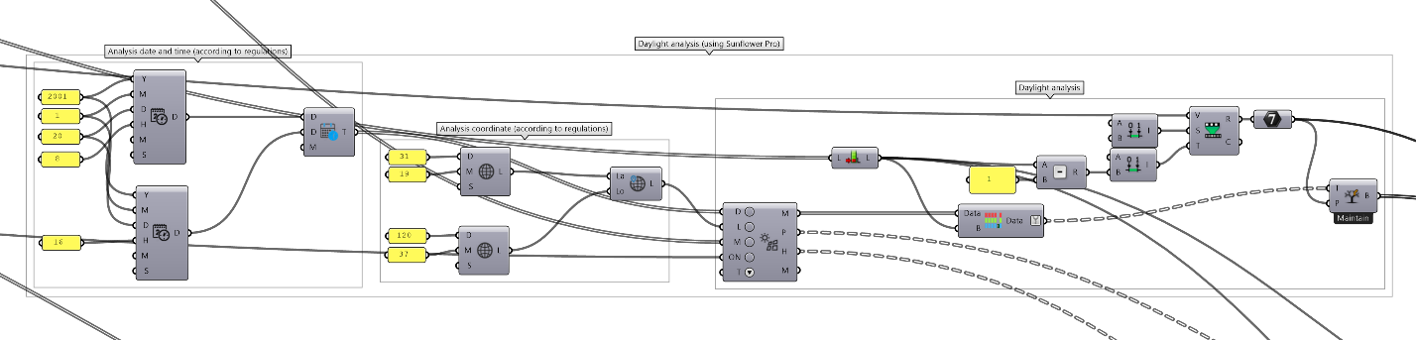

**Fig. 0.** (iv) Daylight analysis – Mapping building

(v) Extract main façade data and check

Then we had collected two data which are coloured mesh and numeric representation of daylight hours and minutes. First, we extracted the data from the main façade only. Second, we mapped the numeric outputs to their respective mesh locations such that we can read the exact daylight hours and minutes on the mesh display. Finally, we compared the extracted daylight hour outputs to the minimum 2-hour requirement and generated a True/False list for easier checking whether the design compiled with the regulations or not. (Fig.0 - (v))

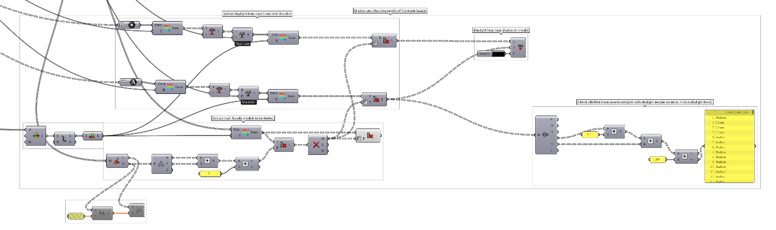

**Fig. 0.** (v) Extract main façades data and check with daylight regulation

**3. Results**

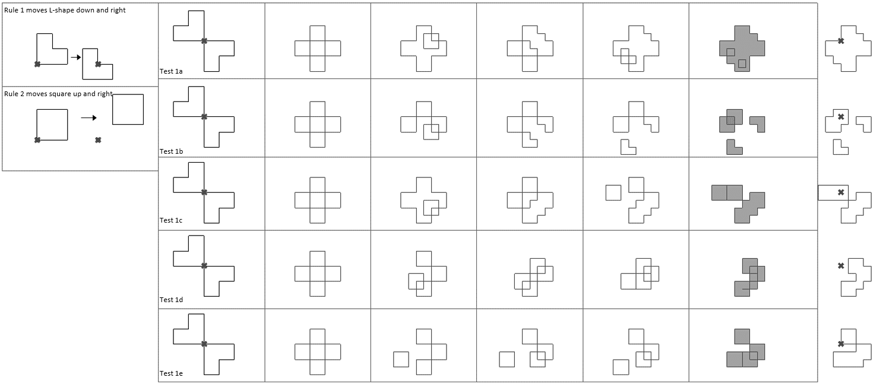

**Fig. 0.** Test 1 – five shape grammar tests (test 1a – 1e)

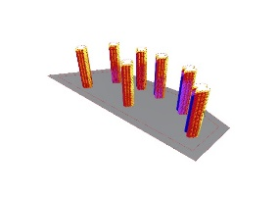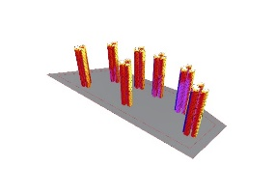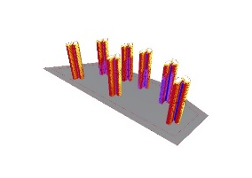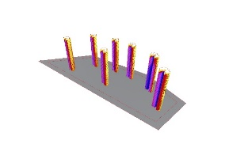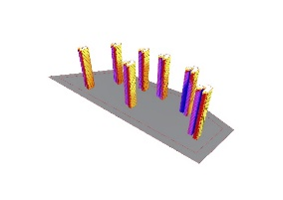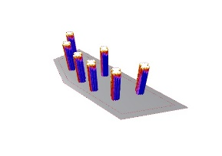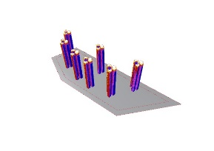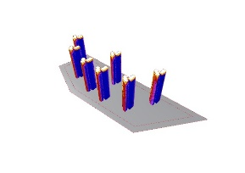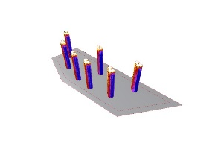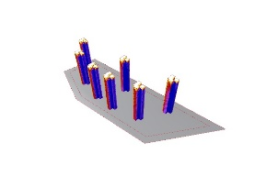

**Fig. 0.** Test 1 – five tests daylight simulations (S-W façade and N-E façade)

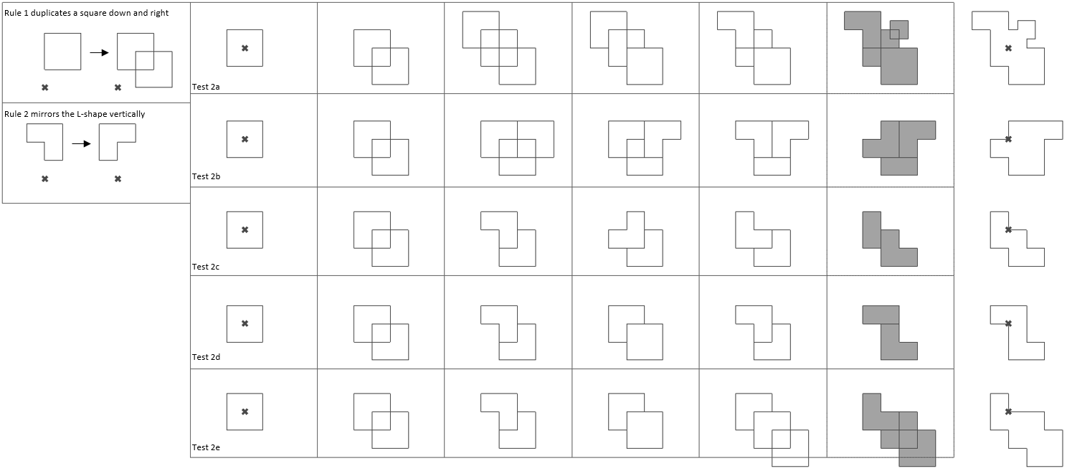

**Fig. 0.** Test 2 – five shape grammar tests (test 2a – 2e)

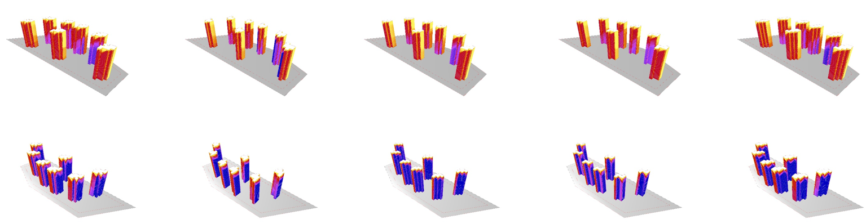

**Fig. 0.** Test 2 – five tests daylight simulations (S-W façade and N-E façade)

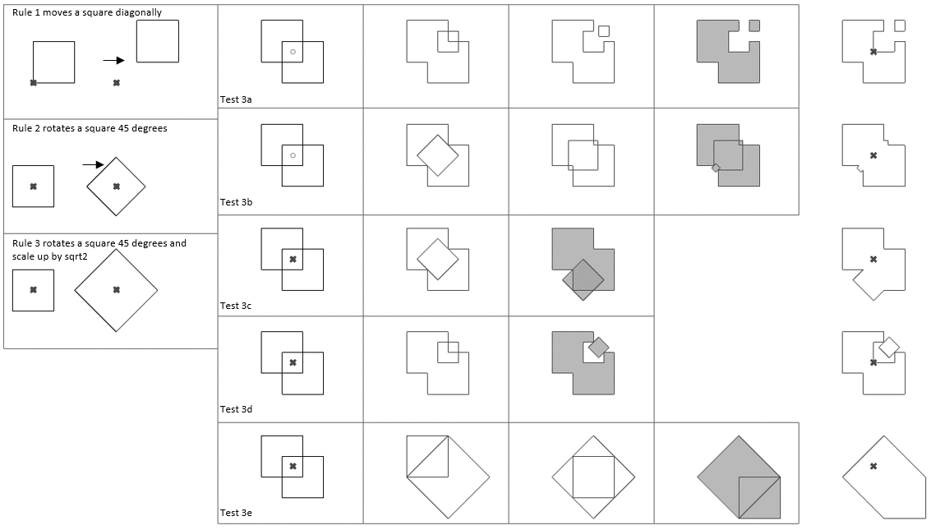

**Fig. 0.** Test 3 – five shape grammar tests (test 3a – 3e)

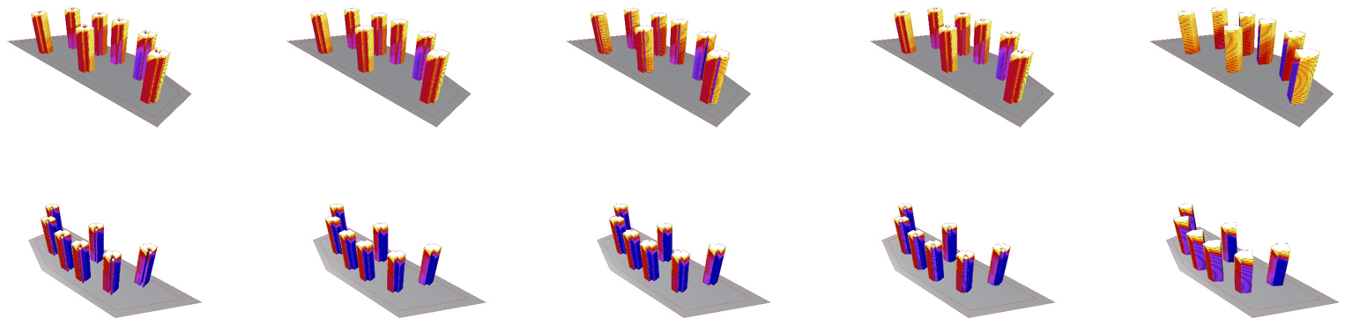

**Fig. 0.** Test 3 – five tests daylight simulations (S-W façade and N-E façade)